Ada — BAN240 Character Sheet
✦ Manga Character Profile Dossier ✦
Character: Adaeze "Ada" Okonkwo | Course: BAN240 | Role: Ensemble Heart | Year: 2nd Year, Business Analytics
BAN240 · Toronto Metropolitan University · Character Reference Document
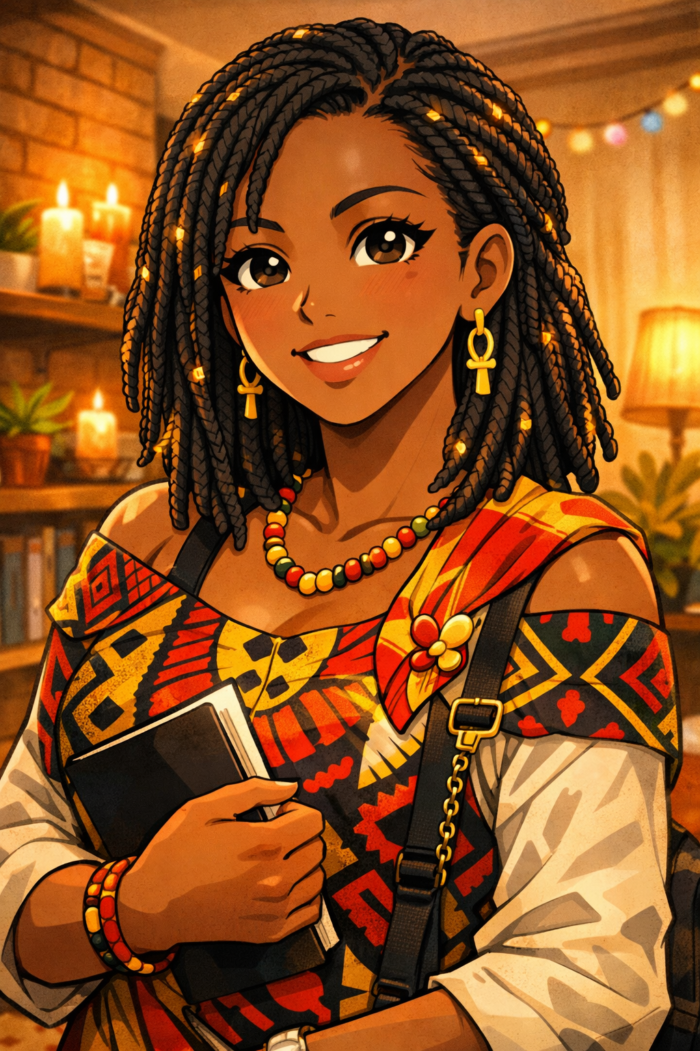

01 · BIOGRAPHICAL OVERVIEW

Ada is a fully realized manga character — a 22-year-old Igbo woman from Enugu whose warmth, creative intelligence, and fierce cultural pride make her the character who makes every space feel intentionally inhabited. She is distinct from Emeka (also Nigerian, also Igbo, from Lagos) in every register: where he is kinetic and entrepreneurial, she is steady and expressive; where his Lagos background is loud and fast, her Enugu roots are grounded and communal.
She came to Canada carrying the specific warmth of an Enugu upbringing — close family, strong community, the sound of Igbo on Sunday mornings — and she is building a version of that warmth in Toronto, one intentional connection at a time.

02 · DEMOGRAPHICS & BASIC INFORMATION

Full Name | Adaeze "Ada" Okonkwo
Age | 22
Gender | Female
Ethnicity | Nigerian — Igbo (Enugu State)
Hometown | Enugu, Enugu State, Nigeria
Current City | North York, Ontario, Canada
Living Situation | Shares a warm, plant-decorated two-bedroom apartment with one other Nigerian female student. The apartment has a specific smell — jollof rice, incense, and whichever candle Ada found at the dollar store this month — that guests comment on positively.
Immigration Status | International student visa
Languages | Igbo (native — she uses it with family and considers it a form of love); English (fluent and expressive, with Nigerian cadences intact)
Occupation | Full-time undergraduate student; runs a small event decoration side business (birthdays, small parties, occasional TMU events)
University | Toronto Metropolitan University (TMU)
Program | Business Analytics
Year | 2nd Year

03 · PHYSICAL APPEARANCE & MANGA PORTRAIT NOTES

Physical Profile

Height | 5'5"
Build | Soft and rounded; moves with ease and presence; takes up her full space without apology
Hair | Natural 4C hair in protective styles — currently medium-length knotless braids with subtle gold thread woven through; changes style every 6–8 weeks with genuine excitement about the next one
Eyes | Dark brown, large and warm — the eyes that make strangers feel seen; sparkle mode reserved for Afrobeats and a perfectly executed event decoration setup
Skin Tone | Deep warm brown with red undertone
Typical Outfit | Bold print co-ord set OR an oversized tee with colourful accessories — aesthetic principle: "at least one thing in the outfit has to make a decision"; always has earrings; the earrings are always the statement
Accessories | Large statement earrings (rotating daily collection); a tote bag that is slightly too full; at least one scarf or wrap; phone case custom-printed with a photo of her family

Manga Art Style Notes

✦ Artist Direction
• Full-face expressions — her emotions are large, legible, and joyful by default
• Sparkle-eyes specifically for Afrobeats moments and beautiful decoration setups
• Dramatic warmth-glow panels when she is in full community mode
• Chibi mode when she sees a decoration idea she wishes she had thought of
• Braids with gold thread are always rendered accurately — a consistent visual signature
• The family phone case is a recurring visual detail; never omit it

04 · PERSONALITY & QUIRKS
- Operates on a frequency of expressed warmth specific to an Enugu upbringing: the assumption is that people are good, that food should be shared, that community is built by showing up
- Has an aesthetic eye that is underestimated because it is deployed with joy rather than coolness — her event setups are genuinely beautiful
- Knows everyone's business not because she is nosy but because people tell her things; she listens in a way that makes people feel their story is worth telling
- Speaks Igbo to her parents on the phone and feels it in her chest; considers Igbo the language that holds things English cannot
- Her event decoration side business started because a friend needed help with a birthday and Ada's setup was so good that three people asked for her number; she has since completed 14 events
- Gets genuinely, physically excited about good Afrobeats — her body responds before her brain does; this is noted by everyone who has ever been near her when the right song plays
- Homesick for Enugu's specific community texture: the noise of Sunday after church, her mother's ofe onugbu, the way her family's compound fills when everyone is home
- Nigerian aunty energy already fully present at 22: will feed you, will ask about your plans, will tell you the truth with love, will pray for you before you leave

"God is testing my patience. I am passing. Barely."
— Ada, on subway delays before a client consultation

05 · HOBBIES & INTERESTS

01 · Event Decoration & Design
Her creative business and genuine passion. Specialises in balloon installations, floral arrangements, table setups, and themed parties. Follows global decoration trends and adapts them with West African aesthetic influences. This is where her analytics mind meets her creative one — budgeting, client management, trend forecasting. 14 events completed. Growing.

02 · Cooking Igbo Food
Ofe onugbu (bitter leaf soup), ofe akwu (palm nut soup), jollof rice (Igbo style — she will explain the differences), fried plantain, puff puff. Cooking is her love language and her primary homesickness response. The Tupperware in her bag is never empty.

03 · Afrobeats & Afropop
Burna Boy, Wizkid, Tems, Ayra Starr, Rema. Music is full-body for her. Curates her event playlists with professional precision. Also follows Igbo highlife — Chief Stephen Osita Osadebe is foundational, inherited from her father. This music is home at a frequency other music does not reach.

04 · Fashion & Personal Style
Follows Afro-centric fashion designers and Nigerian style influencers. Her own aesthetic is bold-and-considered. She thrifts and customises rather than buys fast fashion. The earrings are the thesis statement of every outfit.

05 · Community Building
Attends Toronto Nigerian community events, church (Pentecostal — important to her social and spiritual life), and campus multicultural events. She is the person who brings people who don't know each other into the same conversation.

06 · TikTok & Content Creation
Posts decoration before/after content and "Nigerian student in Canada" life content. Her decoration videos perform well. She has been offered a brand partnership she is considering seriously.

06 · SPORTS

Category | Details
Fan Sport (Primary) | Football — Nigeria Super Eagles. AFCON is a household event. She and Emeka would watch AFCON together and disagree about the starting lineup with the specific energy of two people from the same country who grew up in entirely different Nigerias.
Participatory Sport | None formal. Her physical energy goes into decoration setups, which involve considerably more lifting than people assume.
Fan Sport (Secondary) | Athletics — follows Nigerian sprinters in World Championships and Olympics; Tobi Amusan and the broader Nigerian athletics program. Considers speed a form of Igbo excellence.
Anime Sports Influence | Haikyuu!! — Watched on her roommate's recommendation. Loved it because "the team learns to trust each other and that changes what they're capable of." This is her specific interpretation and she stands by it.

07 · FANDOMS

# | Fandom | Notes
1 | Super Eagles / AFCON | National football devotion; specific opinions about specific coaches; AFCON watch parties are her social infrastructure
2 | Tems | Favourite artist; considers her voice a specific kind of miracle; has seen her live at a Toronto concert
3 | Burna Boy | African Giant resonates deeply; the Igbo diaspora pride dimension is specifically felt
4 | Ayra Starr | Recent fandom; considers her the most exciting new voice in Afropop; "Rush" in a decoration setup is a specific memory
5 | Chief Stephen Osita Osadebe | Igbo highlife legend; inherited from her father; this music is home at a frequency other music does not reach
6 | Nigerian Fashion & Design Community | Follows Ankara designers, Nigerian fashion weeks, Afrocentric aesthetic creators globally
7 | Haikyuu!! | Community-building reading of the series; specifically the "trust changes capability" arc
8 | Toronto Nigerian Community | Church, diaspora events, WhatsApp groups, shared Sunday dinners; her primary social world — the people who understand her without translation

08 · COMMUTE & DAILY LIFE

Commute Profile

Home Base | North York — near Sheppard-Yonge (she and Yuna live in the same neighbourhood and have not yet discovered this)
Route | Walk to Sheppard-Yonge Station → Line 1 subway southbound → Dundas or Queen → walk to TMU
Duration | ~35 minutes each way
Commute Mood | Afrobeats playlist, full volume in earbuds, head moving slightly — she is the person on the subway who is visibly enjoying themselves; occasionally hums; has been told this is noticeable; has not stopped
Signature Move | Records voice memos of decoration ideas that come to her mid-commute; has 47 voice memos in her "decor ideas" folder; has acted on 12 of them
Transit Pet Peeve | "God is testing my patience. I am passing. Barely." — on subway delays before a client consultation

Daily Routine
- On Campus: Arrives knowing at least three people in the building; has a brief conversation before sitting down; her presence in a room is announced not by volume but by warmth; sets up her workspace including a small printed photo of her family propped against her laptop
- Lunch: Jollof rice from home in a Tupperware, always — no negotiation; the smell is notable; she offers some to anyone sitting near her; this has created two genuine friendships
- After Class: Client work (decoration planning, sourcing, budgeting), a campus community event she is helping organise, or home to cook and FaceTime her mother
- Sunday: Church, family call, and cooking for the week — this is not optional and is not negotiated away

09 · CHARACTER ROLE & NARRATIVE FUNCTION

Ada is the heart of the ensemble — the character whose warmth is so consistent and so genuine that it becomes structural; the group is more itself when she is in it. In a school manga, she is the one who remembers that Céleste's daughter had a doctor's appointment, who brings food on the day of the hard exam, who makes the study group feel like it matters beyond the grade.
Her arc is not about learning to care — she was born knowing how — it is about learning that her creative and analytical gifts are not separate things but the same thing expressed in two registers. The event decoration business and the Business Analytics degree are building toward the same future.
Her most powerful scenes are sensory: the sound of Igbo on the phone, jollof rice warming on the stove, a decoration setup at 1 AM that is more beautiful than the client expected, a voice memo she records on the subway about an idea that turns into something real.

✦ Narrative Role Summary
Function
Expression
Ensemble Heart
The group coheres around her warmth; she is the reason people come back
Emotional Memory
She remembers what matters to others; this is her superpower, not a soft skill
Arc Theme
Creative intelligence and analytical intelligence are the same gift — she learns to claim both
Contrast Foil
Distinct from Emeka in every register: steady vs. kinetic, Enugu vs. Lagos, communal vs. entrepreneurial
Sensory Signature
Igbo on the phone; jollof rice; gold thread in braids; decoration setups at 1 AM; voice memos on the subway

BAN240 — Manga Character Profile Dossier | Character: Adaeze "Ada" Okonkwo
Toronto Metropolitan University · Business Analytics · 2nd Year
This document is a creative character reference for academic use in BAN240. All character details are original and fictional.

